CURRICULUM VITAE

K.KARTHIKEYAN.
116, Maruthampati Village, Villappatti-post, llupur-Taluk,
Pudukkottai-622504 Mannan.mannar483@gmail.com Phone No: 9786056122
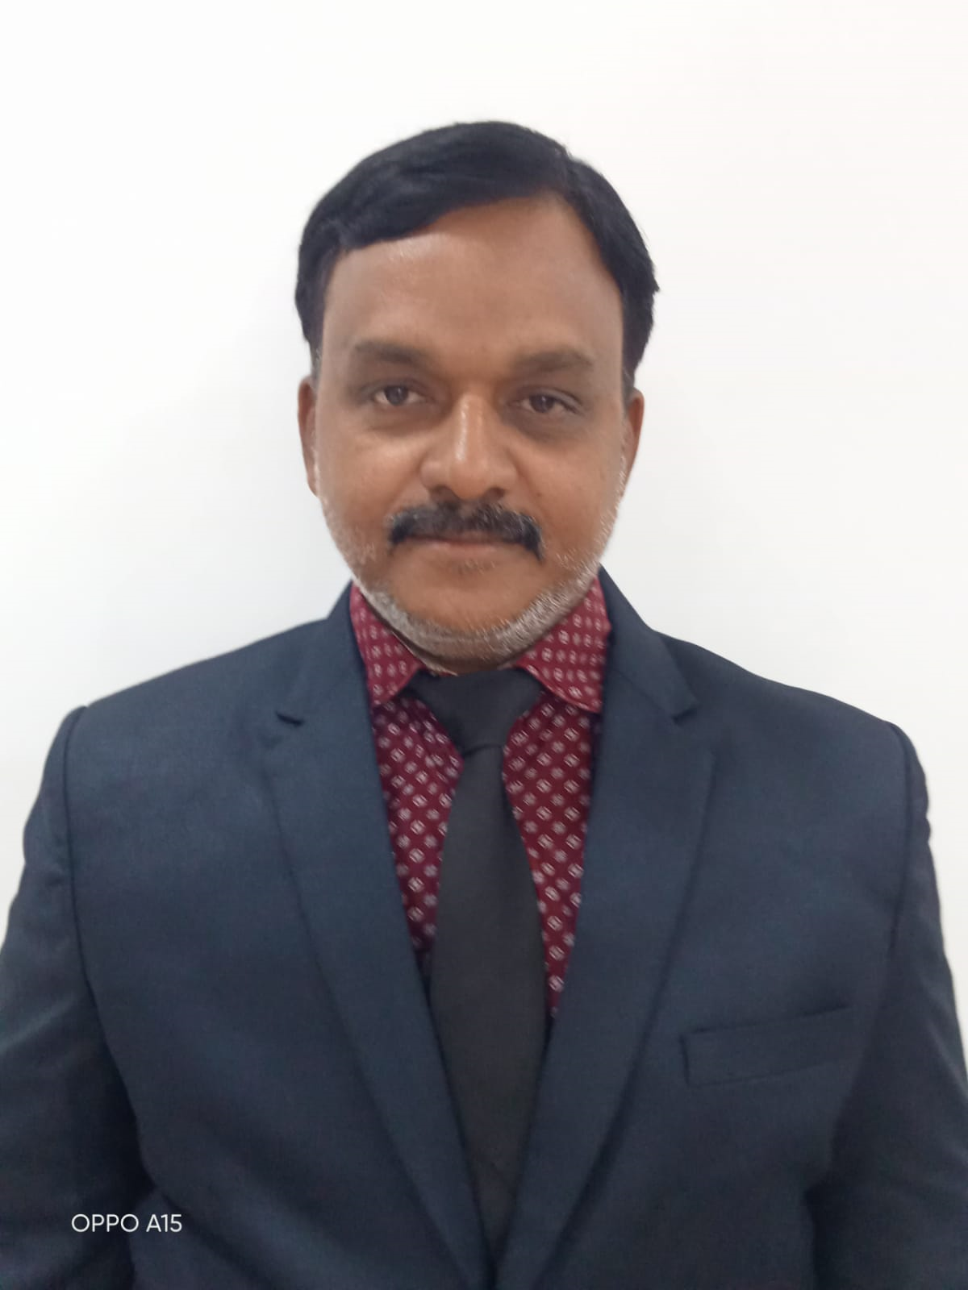
====================================================================================

OBJECTIVE:
To improve my skill and knowledge continuously and perform well in growth professionally. I look forward to an existing and challenging career with an Organization that has congenial working and excellent opportunities.
PERSONAL INFORMATION: Name : K. KARTHIKEYAN.
Father’s Name : R.S. KUNJAIYA.
Sex : MALE
Date of Birth : 19.08.1978
Nationality : INDIAN
Marital status : MARRIED
Religion : HINDU
Languages Known : TAMIL, ENGLISH.,

EDUCATIONAL QUALIFICATION:

COURSE | INSTITUTION/UNIVERSITY | % OF MARK | Year of Passing
B.H.M (Bachelor of Hotel Management) | J.J COLLEGE OF ARTS AND SCIENCE, SIVAPURAM,  PUDUKKOTTAI. | 68 | APRIL 1998
M.T.M (Mater of Tourism Management) | MADURAI KAMARAJ UNIVERSITY, MADURAI. | 65 | NOVEMBER 2007
M.D.C.A (Master Diploma in Computer Applications) Certificate Course | ECIL-BDPS Computer Education Private limited. Truchirappalli  A Government of India Enterprise. | First grade | August 2001
Higher Secondary | T.E.L.C. Higher Secondary School. Pudukkottai. | - | March- 1993
SSLC | T.E.L.C. Higher Secondary School. Pudukkottai. | - | March 1991

AREA OF SPECALIZATION
- Food and Beverage Service, Food Production Theory & Practical
- Food production
- Food and Beverage Service (Theory and Practical).
- Accommodation Management (Theory and Practical).
- Front Office Management (Theory and Practical).
- Travel and Tourism Management.

S.No | Name of the Institution | Designation | From | To | Years of service
1. | Jamal Mohamed College,  Trichy, Tamilnadu. | Assistant  Professor | 10th August  2015 | Till date | 7 Years
2 | Pavendar Bharathidasan College of  Arts and Science. Trichy | Assistant  Professor | 11th August | 09th August  2015 | 12 Years
Total Number of Working years of Experience = 19 years

PARTICPATED IN SEMINAR/ CONFERENCE/ WORKSHOP:

S.NO | TITLE OF THE PAPER | NAME OF THE SEMINAR / CONFERENCE/WORKSHOP AND PLACE | NATIONAL / INTERNATIONAL | DATE
1. | THE ROLE OF A TEACHER IN THE PRESENT SCENARIO | ONE DAY WORKSHOP, ORGANIZED BY  IQAC, JAMAL MOHAMED COLLEGE, TRICHY | - | 10.12.2016
2. | FOOD MELA | FOOD PRODUCTION IN-CHARGE,  JAMALMOHAMEDCOLLEGE, TRICHY-20. | -
3. | NLP-BASED FACULTY EMPOWERMENT  PROGRAMME | THREE DAY WORKSHOP, ORGANIZED BY IQAC, JAMAL MOHAMED COLLEGE,  TRICHY | - | 17, 19,  20.06. 2017
4. | IMPROVING TEACHING  PRACTICES- A STRATEGIC APPROACH | ONE DAY WORKSHOP, ORGANIZED BY  IQAC, JAMAL MOHAMED COLLEGE, TRICHY | - | 23.06.2018
5. | PROFESSIONAL DEVELOPMENT FOR  ACADEMIC LEADERSHIP IN CURRICULUM DESIGN | UGC CPE SPONSORED, TWO DAY WORKSHOP, ORGANIZED BY  CURRICULAM DEVELOPMENT CELL, JAMAL MOHAMED COLLEGE, TRICHY | - | 18,  19.01.2019
6. | CHALLENGES AND  CHANGES IN THE EVALUATION SYSTEM | NAAC NATIONAL SEMINAR,  ORGANIZED BY IQAC, JAMAL MOHAMED COLLEGE, TRICHY | NATIONAL | 26.02.2019
7. | STAFF ENRICHMENT  PROGRAMME ON OWNERSHIP CULTURE | ONE DAY WORKSHOP, ORGANIZED BY  IQAC, JAMAL MOHAMED COLLEGE, TRICHY | - | 14.06.2019
8. | VEGETABLES AND FRUITS CARVING | TWO DAYS WORKSHOP, ORGANIZED BY HMCS, JAMAL MOHAMED COLLEGE,  TRICHY | - | 14TH & 15TH  .10.2019
9. | ORIENTATION PROGRAMME ON PREPARING COURSE  OUTCOMES IN THE CURRICULAM DESIGN | ORGANIZED BY, CURRICULAM DEVELOPMENT CELL, JAMAL MOHAMED COLLEGE, TRICHY | - | 03.01.2020
10. | WORKSHOP ON EDMODO  ICT TOOL | ORGANIZED BY IQAC, JAMAL  MOHAMED COLLEGE, TRICHY | - | 04.02.2020
11. | SPECIAL LECTURE ON “INTELLECTUAL PROPERTY RIGHTS AND PRIOR ART SEARCH FOR  RESEARCH DEVELOPMENT | ORGANIZED BY INTELLECTUAL PROPERTY CELL, JAMAL MOHAMED COLLEGE, TIRUCHIRAPPALLI-620020. | - | 05.02.2020
12. | A Ten day UGC NET/SET Exam Coaching for Paper -I | Organized by the Placement Cell of Jamal Mohamed College |  | 15.02.2020  To 26.02.2021

S.NO | TITLE OF THE PAPER | NAME OF THE SEMINAR / CONFERENCE/WORKSHOP AND PLACE | NATIONAL / INTERNATIONAL | DATE
21. | SPECIAL LECTURE ON  “Believe yourself” | ORGANIZED BY DEPT. OF HMCS,  JAMAL MOHAMED COLLEGE, TRICHY | - | 29.06.2021
24. | SPECIAL LECTURE ON “PARLONS FRANCAIS! Let’s SPEAK FRENCH...!!” | ORGANIZED BY DEPT. OF HMCS, JAMAL MOHAMED COLLEGE, TRICHY | - | 09.07.2021
25. | Special lecture programme is “INDIA LAND OF  MISTERIES” | ORGANIZED BY DEPT. OF HMCS, JAMAL MOHAMED COLLEGE, TRICHY | - | 15.07.2021
27. | Special lecture programme is “BASIC COOKING TECHNIQUES” | ORGANIZED BY DEPT. OF HMCS, JAMAL MOHAMED COLLEGE, TRICHY | - | 04.08.2021

DETAILS OF PAPER PRESENTED:
Details of Papers Presented:

NUMBER OF PAPERS PRESENTED
NATIONAL | INTERNATIONAL
02 | 03

S.NO | TITLE OF THE PAPER | NAME OF THE SEMINAR / CONFERENCE/WORKSHOP AND PLACE | NATIONAL / INTERNATIONAL | DATE
5. | “Contribution of InlandWater Transport in India” | 4TH NATIONAL CONFERENCE ON “HOSPITALITYAND TOURISM INDUSTRIES- A PROMISINGSECTOR OF INDIAN ECONOMY” ORGANIZEDBY  DEPT. OF HMCS, JAMAL MOHAMEDCOLLEGE, TRICHY-20. | NATIONAL | 14.12.2015
9. | "Cruise Tourism In India" | 5TH NATIONAL CONFERENCE ON MANAGEMENT OF TOURISM AND HOSPITALITY SECTORS: CHALLENGES AND REALITIES, ORGANIZED BY DEPT.  OF HMCS, JAMAL MOHAMED COLLEGE, TRICHY | NATIONAL | 21.12.2016
19. | “A Study on Potential Pilgrimage Tourism Destination of Pudukkottai District” | INTERNATIONAL CONFERENCE ON MANAGEMENT OF TOURISM AND HOSPITALITY SECTORS: SUCCESS STRATEGIES ORGANIZED BY DEPT. OF HMCS, JAMAL MOHAMED COLLEGE,  TRICHY | INTERNATIONAL | 23.01.2018
45. | “Covid-19 and its Impact on Travel and Tourism Section” | Second One Day International E-Conference (Online Virtual Conference)  ORGANIZED BY, DEPT. OF HMCS, JAMAL MOHAMED COLLEGE, TRICHY | INTERNATIONAL | 11-11-2020
59 | Entrepreneurship in Tourism and Hospitality Industries: Perspective and Reality” | ONE DAY INTERNATIONAL CONFERENCE, ORGANIZED BY, DEPT. OF HMCS,  JAMAL MOHAMED COLLEGE, TRICHY | INTERNATIONAL | 30-03-2022

  - Acted as organizing committee member in various programmes such as Seminars, Workshops, Guest lectures and Industrial visits organized by the Department of Hotel Management & Catering Science, Jamal Mohamed College (Autonomous), Trichy-20 since 2015.
  - Acting as Bharathidasan University Representative in Board of Studies of Hotel Management & Catering Science, JJ College of Arts and Science (Autonomous), Pudukkottai.
  - Acted as Bharathidasan University Representative in Board of Studies of Hotel Management & Catering Science, Thanthai Hans Roever College (Autonomous), Perambalur.

DETAILS OF MEMBERSHIP IN ACADEMIC BODIES
- Acted as member various programmed such as seminars, Workshops, Guest lecture, and industrial visits organized by the department of Hotel Management & Catering science, Jamal Mohamed College(autonomous), Trichy-20. and Pavendar Bharathidasan college of arts and science, Mathur Trichy-24
- Acted as Subject Expert in Board of Studies of Catering Science & Hotel Management in Bharathidasan University. Tiruchirappalli.
- Acted as Subject Expert in Board of Studies of Catering Science & Hotel Management in Sairam College of Arts and Science. Karur.
- Acted as Subject Expert in Board of Studies of Catering Science & Hotel Management in Dhanalexmi Srinivasan College of Arts and Science. Perambalur.
- Member in Board of Studies of Hotel Management in Jamal Mohamed College (Autonomous), Tiruchirappalli.
- Member in Board of Studies in Bharathidasan University, Trichy. Tamilnadu. Member in Board of Studies in JJ College of arts and Science, Puddukottai. Tamilnadu.

RESPONSIBILITIES HELD IN VARIOUS ACADEMIC BODIES:
- Examiner of Hotel Management Valuation Board(UG&PG), Bharathidasan University.
- Examiner in Hotel Management JJ College of Arts & Science, (Autonomous), Pudukottai.
- Examiner in Hotel Management, Thanthai Hans Roever College of Arts & Science (Autonomous), Perambalur
- Examiner in Hotel Management, Dhanalexmi Srinivasan College of Arts & Science (Autonomous), Perambalur
- Examiner in Hotel Management, Meenakshi Ramasami College of Arts & Science (Autonomous), Thathanur, Jeyankondam.
- Examiner in Hotel Management, Bharath College of Arts & Science, Thanjavour.

Details of Membership in Inspection Committees
- Acted as Inspection Committee Member for granting approval for starting new courses and additional sections in the subject of Hotel Management & Catering Science in three colleges.

DECLARATION:
I do hereby declare that the particulars of information and facts stated above are true, correct and complete to the best of my knowledge and belief.

Place : K. KARTHIKEYAN.
Date :

